May 9, 2018

Grad 2018 - 80’s, 90’s Neon and Glow in the Dark!

The Grad Committee will be decorating the gym in 80’s, 90’s Neon and Glow in the Dark

For the Farewell Ceremony, it is encouraged to have the kids dress up.
(No ripped jeans, no active wear, shorts etc.)

For the Lunch and Dance kids are encouraged to go all out and dress up using the THEME for the day!

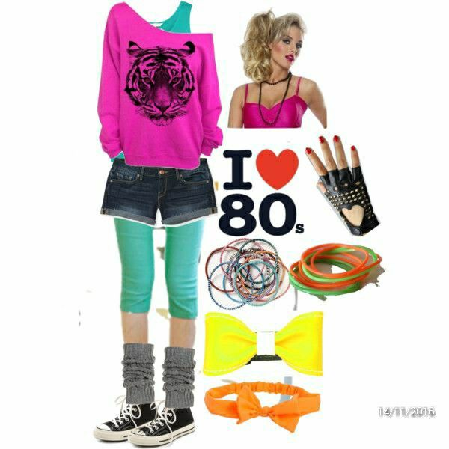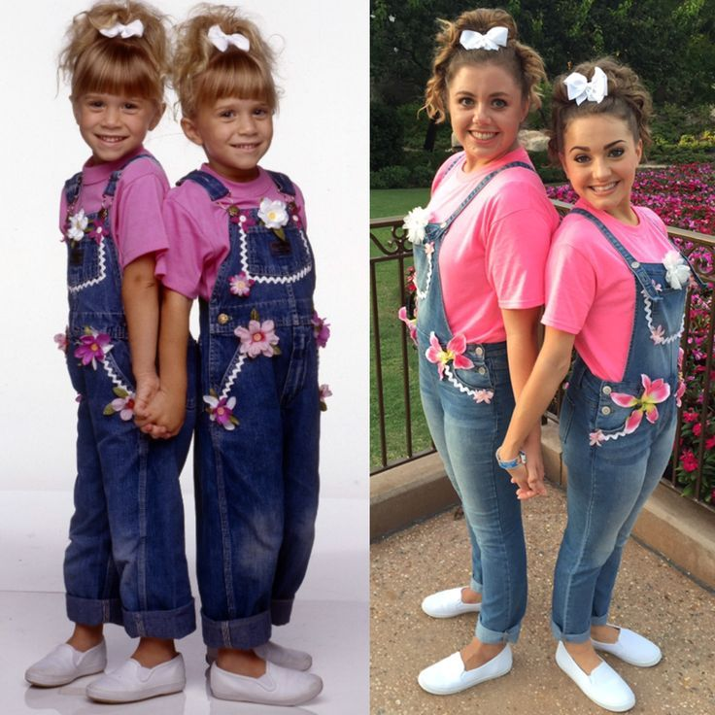

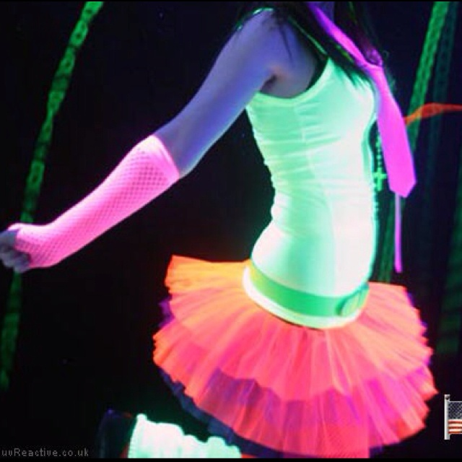
The Grads will be provided Glow sticks for the day from the Grad Committee

Lunch will be from 12:00

The Kids will have from 12:30 to 2:00 to get dressed up into their outfits.

Our Dance will start at 2:30 and end at 5:30pm

We encourage parents to attend from 5:00 to 5:30 to shake it on the dance floor with their Grads!

*** Should you child have a food allergy other than NUTS please email Erin ahead of time at erinmcguire26@gmail.com ****

